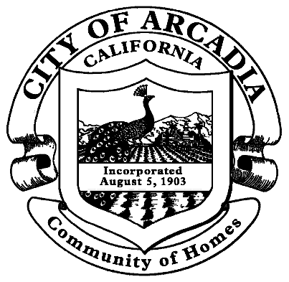

Release & Waiver

Fire Department

RELEASE AND WAIVER OF LIABILITY AGREEMENT
ASSUMING RISK OF BODILY INJURY AND
WAIVING ANY CLAIM FOR DAMAGES
AGAINST THE CITY OF ARCADIA

WHEREAS, the undersigned requests permission to ride as a guest observer in an Arcadia Fire Department vehicle during times when such vehicle is operated by Fire Department personnel in the performance of their official duties;

NOW, THEREFORE, the undersigned assumes the risk of any injury and agrees that the City of Arcadia, its officers and employees, shall not be liable in any manner for any injury to the undersigned, however incurred, while so accompanying said personnel.

 |  | Paramedic Trainee
Name (printed) |  | Fire Academy Cadet
 |  | EMT Student
 |  | Explorer
Signature |  | Arcadia Resident
 |  | Other: (please explain)
Date |  | Ride-A-Long Date(s):_________________

If the guest observer is a minor, the legal guardian must sign the form set forth below:

The undersigned, parent and legal guardian of _______________________________ consents to the above request and waiver of liability and agrees to indemnify and hold harmless the City of Arcadia, its officers and employees, for any loss they may suffer as a result of any claim or suit for damages arising out of the activity referred to in the above request.

Name (printed) |  | Street Address
Signature |  | City, State, Zip
 |  | ( )
Date |  | Phone

