Reserve Truck

705

Inventory

CAB:

* Post Fire Decon kit / First in Guide
* Access Maps / Mass Casualty Guide
* Hazmat Guide / First in Guide
* Apparatus Log / #60182 Note book
* Pre Fire Plans / RIC Pouch
* High Rise Plans

Captains Glove Box:

* Niosh Book
* Chem Book
* Ca, Field Operations
* ERG
* Fire Scope book
* Insurance etc.

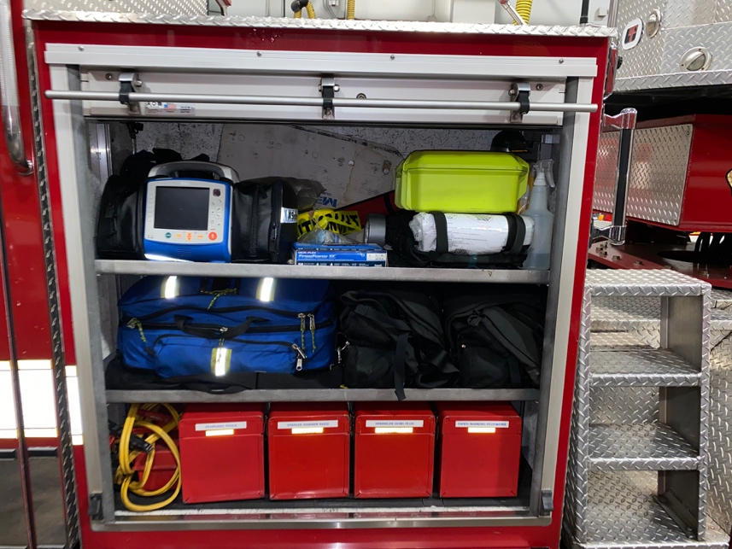

Engineers Roll up 1

* Zoll
* MCI Packs
* Caution Tape / Duct Tape
* N95 / Gloves / Bee Mask / Decon
* Active Shooter Bag
* 4 Web Gear
* Airway bag
* Jumper Cables
* Road Triangles
* Standard Tool Box
* Stapler Hammer Nails Box 8s , 16s
* Sprinkler Dowl Plug box
* Tapes / Marking / Plug n Dike

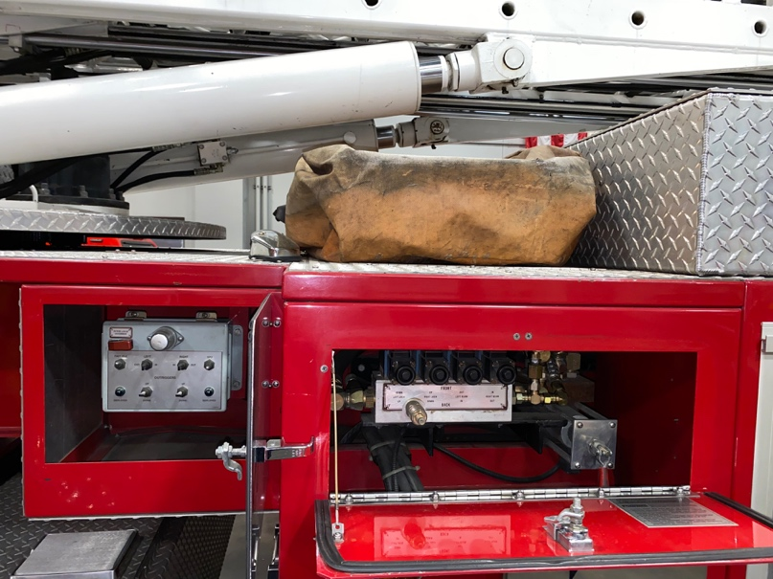

Engineers Middle Cabinets:

* Out Rigger Controls
* Hydraulic Controls
* Stokes basket

Engineers Roll up 2

* Black Box ( Airgun 40 Paratech )
* Orange Bag ( Rescue 42 Attachments )
* Rescue 42s

Engineers Roll up 3

* **Left Pull Out**
* Rubbish Hook
* J-Hooks
* Lock Out Kit
* Shingle Remover Shovel
* Pick Head Axe
* Hot Pole
* 2 wooden handles
* Scoop Shovel
* **Middle**
* Rubbish Hook
* Irons
* Spade Shovel
* NY Hook
* K Tool
* 2 Squeegies
* 2 Scoop Shovels
* **Right Pull Out**
* Sledge Hammer
* Wooden Handle
* Hydrant Key
* Rambar
* Flat Head Axe
* 2 Pry Bars
* Lock out kit
* Push Broom
* Rubish Hook

**Bottom**

* Rotary Saw Stihl 400
* 460 Stihl Chainsaw
* Honda Blower
* Moto Mix
* Extra Chainsaw equipment
* Sthil Bar n Chain oil
* Orange Exhaust Hose

Engineers Roll up 4

* Portable light
* Rice Haul Ash
* Vehicle Jack
* Honda 2000 / 1000
* Step Chalks
* 3 Hurst Rams
* Chains
* Rachet Straps
* Black box ( 3 attachments for Rams )

Engineers Roll up 5

* Air Bag Regulators Box
* Air tools box
* Air hose connection
* 3 Bags of Cribbing
* Lampe Air bags
* Low and high pressure hose

Engineers Roll up 6

* Polyethyln Plastic Salvage Covers
* Vinlyl laminated Nylon Salvage Covers
* Water Proof Woven Cancavs Hall Runners
* 200ft Cord Reel
* Visqueen

Engineers Roll up 7

* Honda 5005
* Ext cords
* 3 portable lights

Rear of Truck

* 16ft Roof
* 20ft Roof
* 20ft roof
* 14ft baby bangor
* 35ft Alum. Ext.
* 28ft Ext.
* 40ft w/ tormentor poles
* 6,8,8,10,10,12 ft Pike Poles

Captains Roll up 1

( starts from rear)

* Honda 50005
* Ext Cords
* 3 Portable Lights

Captains Roll up 2

* Sked
* Ric Bag
* 200ft Cord Reel
* Hardware / Soft Ware
* 2 rope bags
* Harness bag
* Pick off strap bag
* 150ft Search bag

Captains Roll up 3

* 2 SCBA’s
* TIC
* Gear

Captains Roll up 4

* Emergency Blanket
* Hurst Combi Tool
* Hurst Spreaders
* Hurst Generator
* Hydraulic Lines
* Hurst Cutters
* 2 recriprocating saws
* Extra battery
* WD40

Captains Roll up 5

* Stihl Rotary Saw 400
* 460 Stihl Chain Saw
* GX 160 Honda Gen
* Orange Exhaust Hose
* Moto Mix / Oil

Captains Roll up 6

* Akron Gate Valve
* 4’’ double male/female
* Storx Quick Connect 4’’ to 2.5’’
* Ladder Belts
* Edge Roller
* SCBA bottles

Captains Side Middle Body

* Class K Ext.
* Cones
* Out rigger controls

Captains Roll up 7

* Water Vac
* 1 ½ Hose
* CO2/H2O/ABC Ext.
* Sub pump
* Gas Can

Top of Truck / Ladder

* 100ft 3’’
* 2 rope bags 100ft
* Smooth bore tips
* 3 D-Straps
* Fog Nozzle
* Spanners

