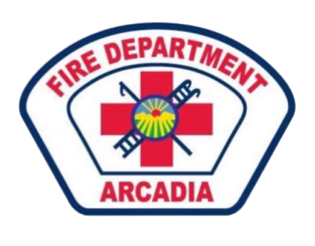

Engine 106 Inventory

**CAB:**

* **FRONT BUMPER: 100ft Scorpion load, 1’’ ½ w/ TSM-20F**
* RIC Pouch
* Kestrel
* Map Book
* Mass Casualty Notebook
* Area C Maps
* First in Guide
* Fire Pre Plans
* E106
* Strike Team Forms
* Wildland Supplies
* MSA Altare 5x
* Gas Trac
* AC Hot-stick

**CAB Engineers Side Comp:**

* Amerex Dry Chem

**Transerve Hose Bed:**

200ft 1 ½ w/ TSM-20F

300ft 1 ¾ w/ TSM-20F

200ft 2 ½

33ft 4’’ Supply hose (both sides)

200ft 1’’ Booster Reel w/ Bubble Cup Nozzle

**LEFT:**

* D-Tank O2
* Class K extinguisher
* Class 2A Water Can

**RIGHT:**

* CO2 Extinguisher
* Fuel Intake

Tool Compartment ( Engineers 2nd ) :

* **OUTER DOOR**
* 36’’ Bolt Cutters
* 8lbs Sledge Hammer
* IRONS
* **INNER DOOR**
* Squeegee Head
* Pulaski
* Ram Bar
* K-Tool
* **INNER COMPARTMENT**
* Hot Pole
* Wooden Handle (Squeegee)
* Spade Shovel
* Mcloud
* Pry Bar
* Fiberglass Handle (push broom)
* Crowbar
* Vehicle Lock out kit

**Engineers 3rd Comp:**

* 2 SCBA’S
* 2 Web Gear
* Road Cones
* Rice Hull ASH

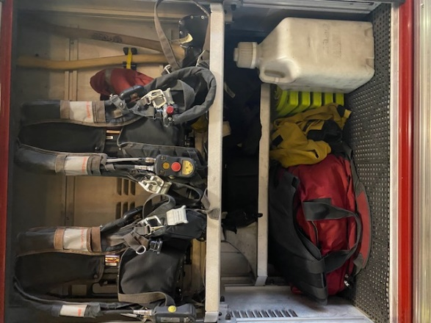

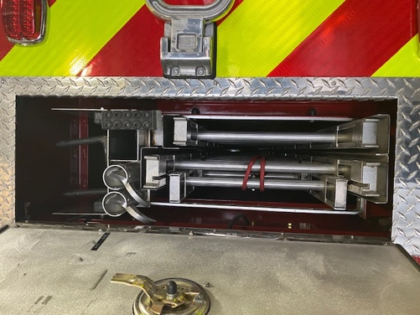

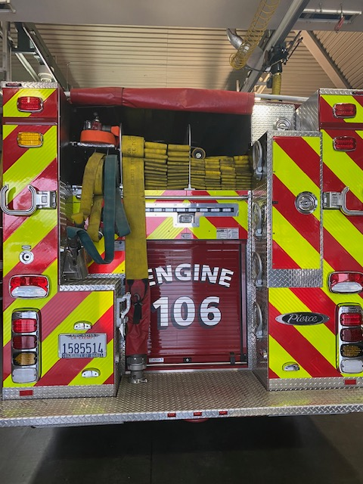

Rear:

* 2 Miami’s 200ft

1 ¾ w/ TSM-20F

* High Rise Pack 100ft 1 ¾ w/ wye TSM-20F
* 800ft 4in Supply w/ bullet & Hyd.
* 800ft 2 ½ w/ TSM-30F

Ladder Comp:

* 10ft Attick
* 14ft Roof
* 24ft Ext.
* 6&8ft Pike poles
* Rubbish Hook

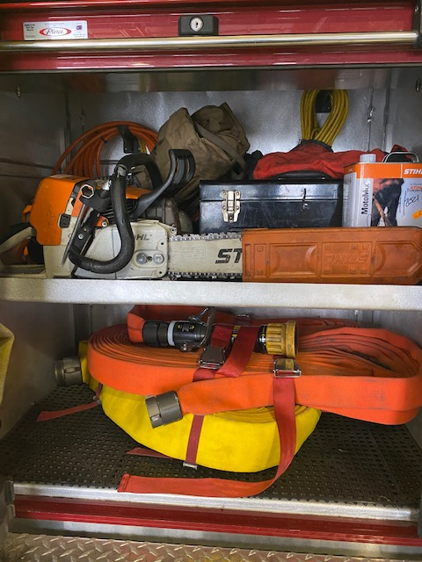

**Rear Comp:**

* 461 Stihl Chainsaw
* Tooll Bag
* Tool Box
* Moto Mix / Bar Oil
* Air line
* Jumper Cables
* Sum. Pump
* Chaps
* High Rise Pack 100ft 1 ¾ w/ TSM-20F
* 50ft 2 ½

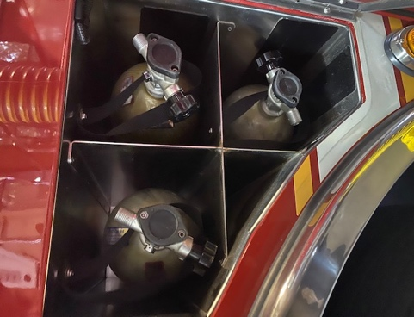

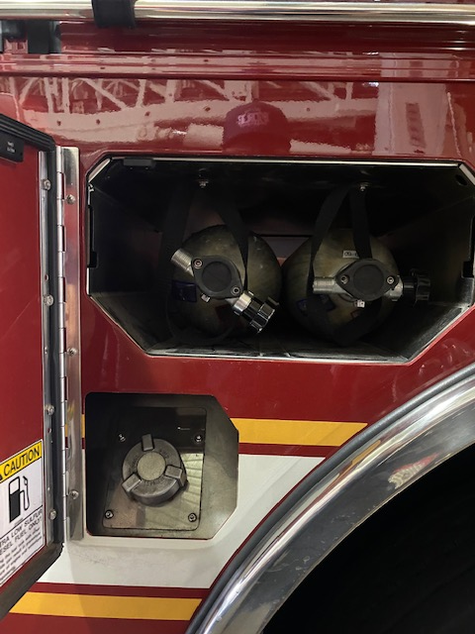

Side Comp

(5) 45min Cyl

Fuel Intake

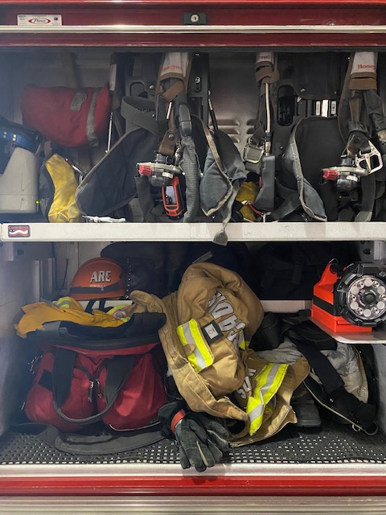

Captains Compartment:

* TIC
* 2 SCBA’s
* Seek TIC
* 2 WEB Gear
* Box Light

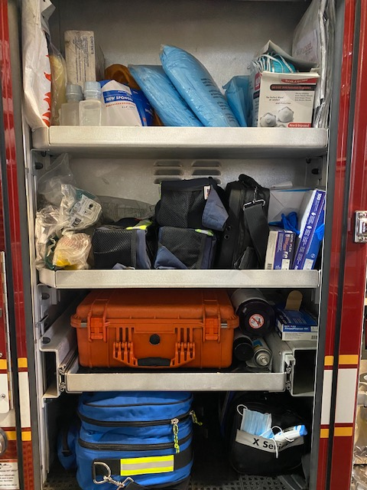

Captains Middle Comp:

* Salvage Covers
* WMD Bag
* Active Shooter
* (3) Ballistic hel.
* Ric Bag
* 150ft Search Bag

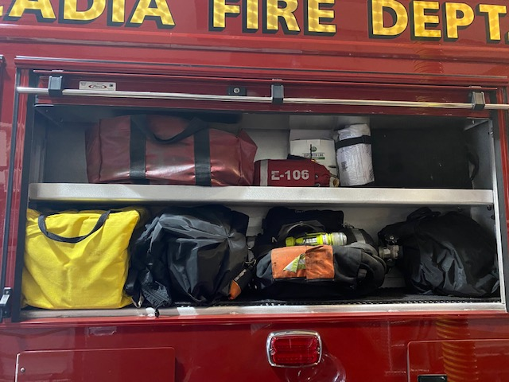

EMS Compartment:

* Burn Sheets / Trauma Sheets
* Infection control kit
* OB Kit / Gowns / Masks
* Mega Mover / Saline
* MCI Packs / AED / Gloves
* BVM’s / C-Collars
* PM Box / decon wipes
* Airway bag / zoll

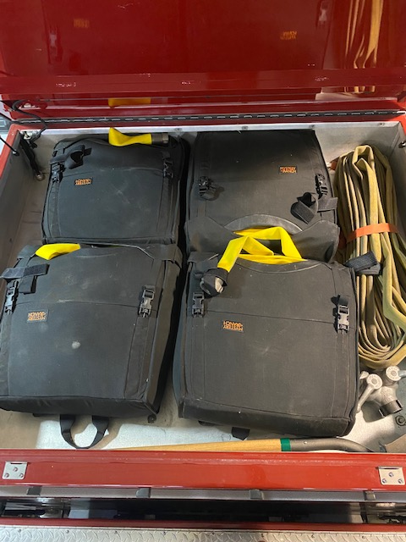

Wildland Compartment:

* 4 Smokey Packs

100ft 1.5’’ Trunk line w/ 100ft 1’’ wye and 60/40 Nozzle

* Starter Pack 100ft 1’’ w/ wye and 60/40 nozzle
* Flat Nose Shovel

Deck Gun Comp:

* Deck Gun
* Ground Monitor
* 200ft 1’’ Booster Reel
* Fire Aid Foam
* Sooth Bore Tips

1 3/8, 1 ½ , 1 ¾ , 2’’

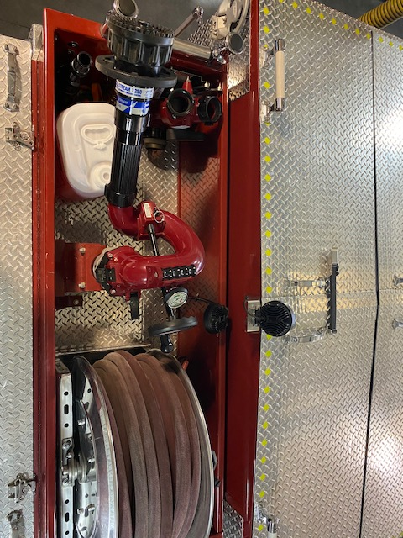

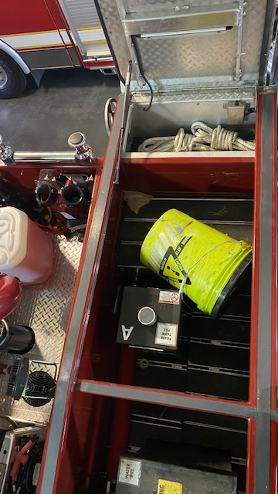

Top Middle Comp:

* Water Fill Tank
* Foam Fill Tank
* Post Fire Decon Kit
* 2 Utility Rope
* Aerator Nozzle

Captains Top Coffin:

* Gatorades
* Visqueen
* Utility Rope Bag
* 150ft Rope bag
* Class 3 harness bag
* Pick off bag
* Hydrant Key
* Mechanical Axe
* Hardware Software bag
* Cots / Foldable Chairs
* Cot Padding

Engineers Top Coffin:

* REI Camp Dome
* Cots / Foldable Chairs

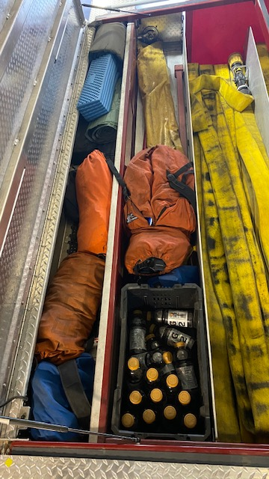

Engineers Cabinet: Drawer 1

* Black Ratchet straps
* Flow Charts
* Tire Guage
* Air Chuck
* Sharpie / Super Glue / White Polish
* Gaskets

Drawer 2 Key

H = Hose

P = Pipe

DBL = Double

M = Male

F = Female

v = Reducer

^ = Increaser

“=” = Same Diameter

**4’’ DBL M & F**

**2.5’’ DBL M**

**2.5’’ Discharge Cap**

**2.5’’H v 1.5’’H**

**1’’ DBL F /P**

**2.5’’ DBL F**

**1’’H v 1/2’’P**

**1’’H=1’’H**

**1/2’’ DBL F / P**

**1.5’’ DBL F / H**

**1’’H ^ 1.5’’H**

**1.5’’ DBL M / H**

**1.5’’H v 1/2 ‘’ P**

**1.5’’H v 1’’H**

**1.5’’H v 1’’P**

**1’’H=1”P**

**1’’P=1’’H**

**1’’ DBL M / H**

**Drawer 4:**

* Water Ejector
* Strainer
* Siamese / Wye
* Trash Bags
* 60/40 nozzles
* Wildland Ts
* 1.5in Wye
* .5’’ Garden Hose
* Brensen Cellar
* 1.5’’P<2.5H increaser
* 2.5’’ Discharge cap
* Foam educator on side

**Drawer 3:**

* 4in Spanners/ Spanners/ Mallet
* Plug n Dike/Elec/Caut/Duct/Flagging/WD40
* Bullet 2.5<4 increaser
* Foam Wrench / Hydrant Wrench.

**Drawer 4**

**Drawer 3**

**Drawer 2**